
Grace Dodge Career & Technical High School
2474 Crotona Avenue, Bronx, NY 10458
Roberto Hernandez, Principal (718) 584-2700
G. Sullivan, English Curriculum Coordinator

Dear Students,
Welcome to the 9th Grade Academy of Grace Dodge Career and Technical High School! As part of our continued effort to help you successfully make a transition from middle school to high school, we require that you complete two summer reading projects.
The Global History and English Teachers are currently writing a humanities curriculum for next year. This course will combine the 9th & 10th grade Global and 9th grade English courses. In order to help you get a head start, the following selection of projects and readings reflect the kinds of activities and texts you will experience during the year.
Choose and read one biography and one novel of historical fiction from the list. After you have read a biography and a historical fiction novel, choose a biography project from the list and choose a novel project from the list.
The two projects will be graded using the attached rubric. You should refer to the rubric to ensure a good grade on your projects.
Your project grades will count as test grades for the first marking period.
Start your freshman year off well by handing in your biography project to your Global studies teacher and your historical fiction novel project to your English teacher the first week of school!
See you in September!

Roberto Hernandez
Principal

Project Options for biography:
A graphic novel (a comic book for grownups) Use your artistic talents to create an original piece of work derived from your book. Use all the conventions of graphic novels, for instance, dialogue bubbles above characters, different fonts, etc.
Children’s book Create a children’s book which summarizes the story. Use vocabulary that is appropriate for a child of five or six. Include pictures or drawings on each page or double page. Avoid having too many sentences per page. The book needs to be at least ten pages long with a cover and title page.
A series of correspondence (letters, emails, IM’s, phone conversations) between and among characters in the book What information would this correspondence contain that could shed more light on the characters? (Make it look authentic!)
Create an illustrated timeline Create timeline with the major events of his/her life. For each major event add a brief synopsis and an illustration.
Project Options for novel:
Videotaped dramatization of a scene in the book. Write out an explanation of the scene you taped: Who are the characters? What is the significance of the scene in the novel? What is the significance of the scene to you?
A family tree of key characters with biographies and character descriptions based on your observations and textual evidence.
Main Character’s Diary Imagine that you are a character in the book. You do not have to select the main character; however, you may if you choose. Write at least ten diary entries that this character might have made concerning the events that take place in the novel.
Front page of a newspaper Create a newspaper (choose a name for it that is related to the novel, but not the name of the novel). You need only do the front page. Plan stories that relate to events in the novel. For example, if your novel contains a murder, write the account of the murder as it would appear in a real newspaper—just the facts. Include other stories and some graphics just as a real paper would.
Talk show Create a talk show style interview with one of the characters from the novel. Ask questions (at least fifteen) of the character that give an insight into the character, the action of the book, and the character’s reaction to it. Write out the questions and answers. You may video the interview or record a tape.
Game Create a board game that represents the events of the novel. You may use tokens that are symbols that appear in the book. Game cards that offer rewards and penalties based on events in the novel may be used for advancing the tokens around your board. Write a set of game rules to explain how the game is played and how the game is won.

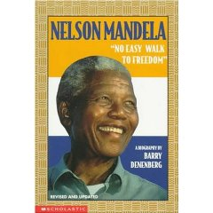
Biographies
Nelson Mandela: No Easy Walk To Freedom (Biography)
- Reading level: Ages 9-12
- Paperback: 164 pages
- Publisher: Scholastic Inc.
- ISBN-10: 059044154X
- ISBN-13: 978-0590441544
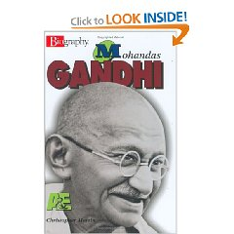
Mohandas Gandhi (Biography)
- Reading level: Ages 4-8
- Hardcover: 112 pages
- Publisher: Lerner Publications
- ISBN-10: 0822549840
- ISBN-13: 978-0822549840
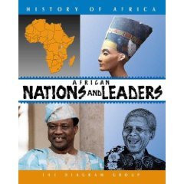
African Nations and Leaders (History of Africa)
- Reading level: Young Adult
- Hardcover: 112 pages
- Publisher: Facts on File (June 2003)
- ISBN-10: 081605066X
- ISBN-13: 978-0816050666
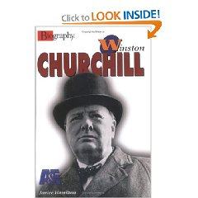
Winston Churchill (Biography)
- Reading level: Ages 9-12
- Library Binding: 112 pages
- Publisher: Twenty-First Century Books
- ISBN-10: 0822534193
- ISBN-13: 978-0822534198
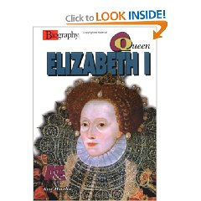
Queen Elizabeth I (Biography)
- Reading level: Ages 9-12
- Hardcover: 112 pages
- Publisher: Lerner Publications (May 2002)
- ISBN-10: 0822500299
- ISBN-13: 978-0822500292
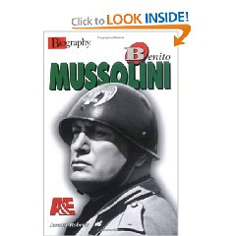
Benito Mussolini (Biography)
- Reading level: Young Adult
- Library Binding: 112 pages
- Publisher: Lerner Publishing Group (2005)
- ISBN-10: 0822526484
- ISBN-13: 978-0822526483
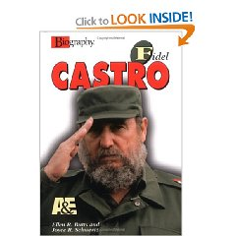
Fidel Castro (Biography)
- Reading level: Ages 9-12
- Library Binding: 112 pages
- Publisher: Lerner Publications
- ISBN-10: 082252371X
- ISBN-13: 978-0822523710
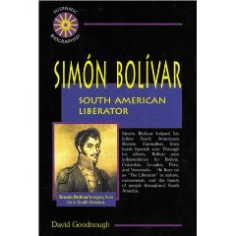
Simon Bolivar: South American Liberator (Biography)
- Reading level: Young Adult
- Library Binding: 128 pages
- Publisher: Enslow Publishers
- ISBN-10: 0766010449
- ISBN-13: 978-0766010444
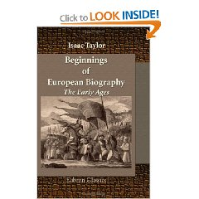
Beginnings of European Biography. The Early Ages:
- Paperback: 196 pages
- Publisher: Adamant Media Corporation
- ISBN-10: 1421269473
- ISBN-13: 978-1421269474
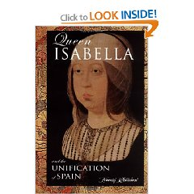
Queen Isabella: And The Unification Of Spain (Biography)
- Reading level: Ages 9-12
- Library Binding: 160 pages
- Publisher: Morgan Reynolds Publishing
- ISBN-10: 1931798257
- ISBN-13: 978-1931798259
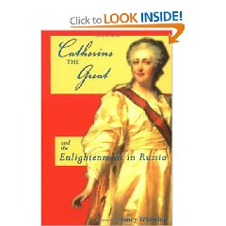
Catherine The Great: The Enlightenment In Russia (Biography)
- Reading level: Ages 9-12
- Library Binding: 160 pages
- Publisher: Morgan Reynolds Publishing
- ISBN-10: 1931798273
- ISBN-13: 978-1931798273
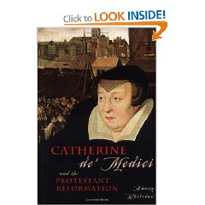
Catherine De' Medici: The Protestant Reformation (Biography)
- Reading level: Ages 9-12
- Library Binding: 160 pages
- Publisher: Morgan Reynolds Publishing
- ISBN-10: 1931798265
- ISBN-13: 978-8425334726
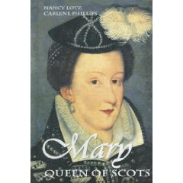
Mary Queen of Scots (Biography)
- Reading level: Young Adult
- Library Binding: 160 pages
- Publisher: Morgan Reynolds Publishing
- ISBN-10: 1599350408
- ISBN-13: 978-1599350400
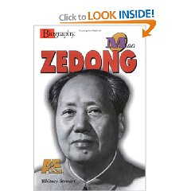
Mao Zedong (Biography)
- Reading level: Young Adult
- Library Binding: 112 pages
- Publisher: Twenty-First Century Books
- ISBN-10: 0822527979
- ISBN-13: 978-0822527978
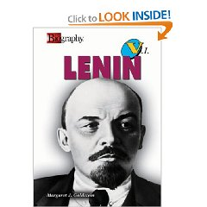
V. I. Lenin (Biography)
- Reading level: Young Adult
- Library Binding: 112 pages
- Publisher: Twenty-First Century Books
- ISBN-10: 0822559773
- ISBN-13: 978-0822559771
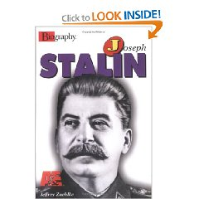
Joseph Stalin (Biography)
- Reading level: Ages 9-12
- Library Binding: 112 pages
- Publisher: Twenty-First Century Books
- ISBN-10: 0822534215
- ISBN-13: 978-0822534211
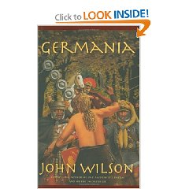
Novels
Germania
- Reading level: Young Adult
- Hardcover: 280 pages
- Publisher: Key Porter Books
- ISBN-10: 1554701120
- ISBN-13: 978-1554701124
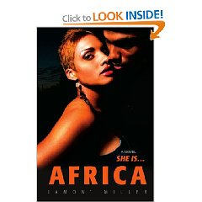
Africa (Mythology)
- Reading level: Ages 9-12
- Paperback: 300 pages
- Publisher: iUniverse, Inc.
- ISBN-10: 0595369731
- ISBN-13: 978-0595369737
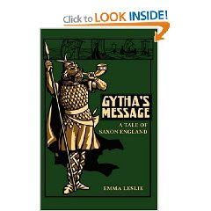
Gytha's Message: A Tale of Saxon England
- Reading level: Ages 9-12
- Hardcover: 256 pages
- Publisher: Salem Ridge Press
- ISBN-10: 1934671118
- ISBN-13: 978-1934671115
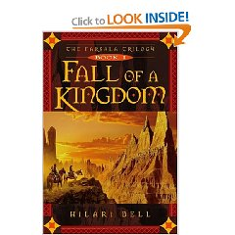
Fall of a Kingdom (Farsala Trilogy, Book 1)
- Reading level: Young Adult
- Mass Market Paperback: 448 pages
- Publisher: Simon Pulse (January 6, 2005)
- ISBN-10: 0689854145
- ISBN-13: 978-0689854149

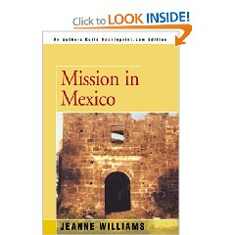
Mission in Mexico
- Reading level: Young Adult
- Paperback: 196 pages
- Publisher: iUniverse, Inc
- ISBN-10: 0595146422
- ISBN-13: 978-0595146420
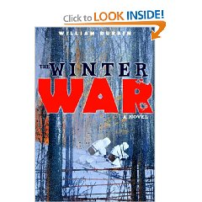
The Winter War: A Novel
- Reading level: Young Adult
- Hardcover: 240 pages
- Publisher: Wendy Lamb Books
- ISBN-10: 0385746520
- ISBN-13: 978-0385746526
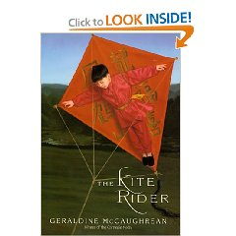
The Kite Rider
- Reading level: Ages 9-12
- Hardcover: 288 pages
- Publisher: HarperTeen (June 18, 2002)
- ISBN-10: 0066238757
- ISBN-13: 978-0066238753
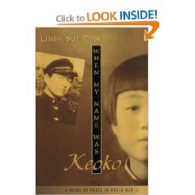
When My Name Was Keoko
- Reading level: Young Adult
- Hardcover: 208 pages
- Publisher: Clarion Books
- ISBN-10: 0618133356
- ISBN-13: 978-0618133352
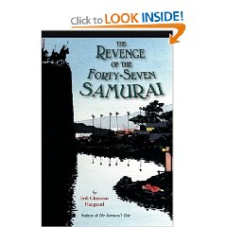
The Revenge of the Forty-Seven Samurai
- Reading level: Young Adult
- Hardcover: 240 pages
- Publisher: Houghton Mifflin Books for Children (April 24, 1995)
- ISBN-10: 0395708095
- ISBN-13: 978-0395708095

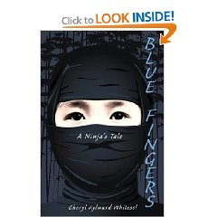
Blue Fingers: A Ninja's Tale
- Reading level: Ages 9-12
- Hardcover: 256 pages
- Publisher: Clarion Books (March 22, 2004)
- ISBN-10: 0618381392
- ISBN-13: 978-0618381395

Summer Reading Project Rubric
Top of Form
 | Poor  5 pts | Fair  10 pts | Good  15 pts | Excellent  20 pts
Organization | Poor  The project is haphazard at best and does not convey meaning. | Fair  This project lacks a clear organizational structure. Meaning is difficult to comprehend because of the lack in organization. | Good  This project is organized effectively, but there are places where the viewer loses focus and cannot clearly understand what is being conveyed. | Excellent  This project is well organized. The viewer can clearly understand what is being conveyed through the project.
Elaboration | Poor  The project does not provide enough detail. | Fair  The project provides some detail, but leaves the viewer of the project with questions. | Good  The project provides enough detail, but may leave the viewer of the project with a question. | Excellent  The project is well detailed, and leaves no questions in the viewer’s mind.
Mechanics | Poor  The project has too many errors for the viewer to understand meaning | Fair  The project has numerous grammatical and spelling errors that significantly impair understanding | Good  The project has a few grammatical and spelling errors but they do not significantly impair understanding | Excellent  The project is free from grammatical and spelling errors
Presentation | Poor  This project is basic and has no creativity whatsoever. | Fair  The project lacks effective presentation skills. It is presented in a basic way and does not attract the viewer's attention. | Good  The project is presented in a creative manner, but lacks an overall positive presentation. There are cross-outs, erasures, etc that distract the viewer. | Excellent  The project is presented in an attractive manner. The viewer identifies quickly with the project and is quickly drawn into wanting to read about the novel.
Voice | Poor  The project does not show awareness of audience or use appropriate vocabulary. | Fair  The project may not show awareness of audience or use appropriate vocabulary. | Good  The project shows awareness of the audience and/or uses appropriate vocabulary. | Excellent  The project shows awareness of audience through tone and uses appropriate vocabulary.
Bottom of Form

