Adding Animation to PowerPoint Presentations
In the main menu, click Slide Show.
Under the Slide Show menu, click Custom Animation as highlighted below.

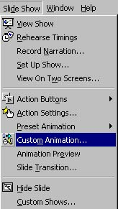

The Custom Animation screen should appear. Click the Timing tab if it is not already selected.
Under the section Slide objects without animation, click WordArt. WordArt is shown highlighted below.

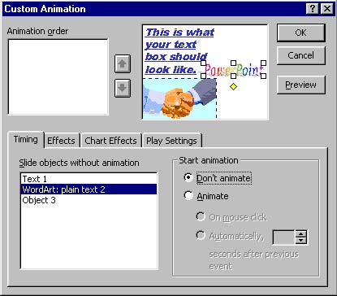

Under the section Start animation, click the bullet to the left of Animate.
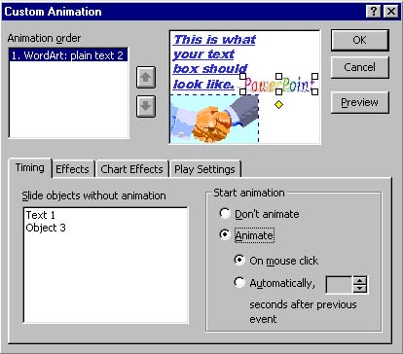
Under Animation order, you can see WordArt listed as number one. This is the only item being animated, so it is listed as the first item in the animation order.
Change the tab to the Effects tab.
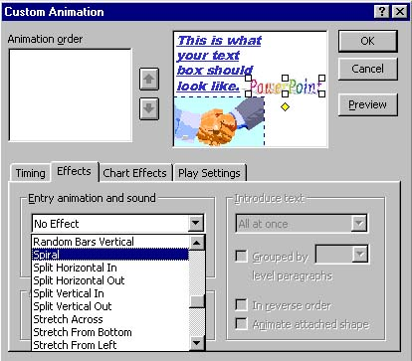

Under Entry animation and sound, click the first down arrow as shown above. Click Spiral.
In the second section under Entry animation and sound, click the down arrow.

From the list that appears, click Drive By.
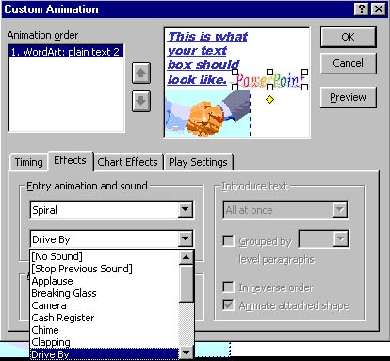

Under the After animation section, click the down arrow button . Click Hide After Animation.
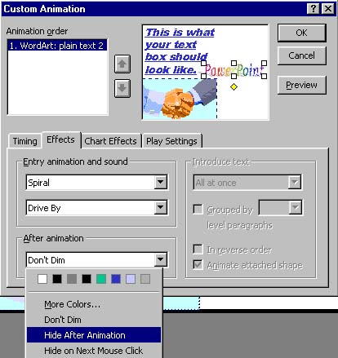
Click Preview to see what the animation will do to your WordArt. Once you are finished, click OK.

