The Port of Valencia, Spain

Available Products: The merchants purchased raw materials, wool, wool products, and wheat grain, and exported them through Valencia to other ports of the Mediterranean and North Africa.

Weather: 45 to 55 degrees in Winter. Water temperatures around 55 degrees. After January temperatures begin to climb to feel almost spring like.

Places of Interest to Visitors: La Lonja, the silk marketplace, El Miguelete, and Torres de Quart, are places often visited by tourists and businessmen. In the 15th century (1600’s) Valencia was one of the most cultured and important trading places in the Mediterranean region.

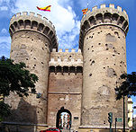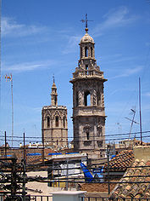
The Torres de Quart The Miguelete Bell Towers

 A Valencia Marketplace

