The Port of Tyre, Lebanon

Available Trade Items: Cotton, cloth, paper, jade, from the east. Cinnamon, black pepper, and spices from India.
Most of these items found their way, through trade, to Italian cities.

Weather: Winter: Rainy, with snow in the mountains. Generally, it is 55 to 78 degrees in the summer.

Points of Interest to Travelers: The Crusader castle in the port, and the ruin of the Roman Hippodrome (sports stadium) which seated 20,000 people, is just outside town.

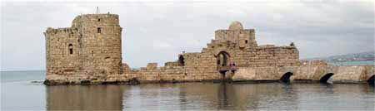
The Crusader Castle in the harbor.

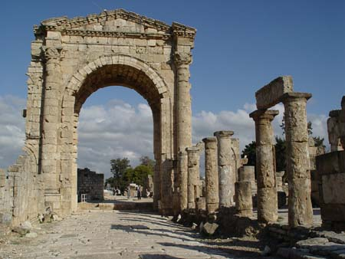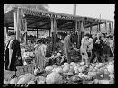
The Roman Hippodrome outside town. Town Square Market

