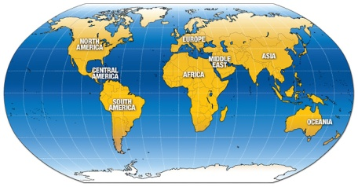
Travelogue GO:
Name _____________
Port City
People/
Culture

Topography/
Land

Landmarks/
Architecture

Trade

Port City
People/
Culture

Topography/Land

Landmarks/
Architecture

Trade

