Seville ( Islamic until 1492 )

Products Available for Trade: Wheat, oil, animal hides, steel swords.

Weather: Winter: Never freezes, mild, but rainy October through December.

Points of Interest to Visitors: The Alcazar, a palace of Muslim rulers, the Plaza de Espana, and notable palaces are often visited.

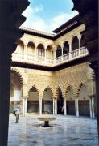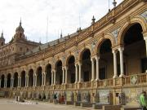
The Alcazar Courtyard The Plaza de Espana of Seville

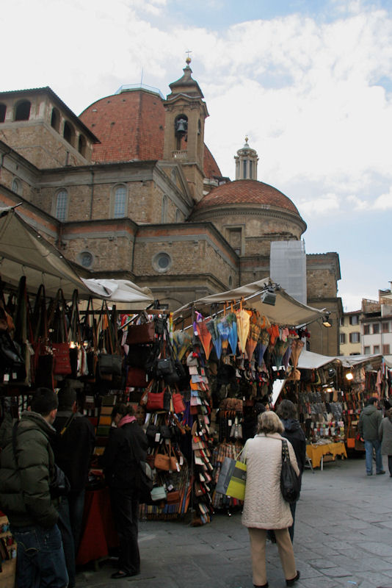
Market scenes in Seville

