The Port of Naples

Products Available for Trade: Grains ( wheat, barley, rye ) were usually traded to other cities of Italy and as far away as Athens, in the Greek Islands, and North Africa.

Weather: Between 40 and 60 degrees in winter.

Points of Interest for Visitors: The Great Naples Castle, the Great Cathedral of Naples, and the beautiful harbor itself are favorite visitor destinations.

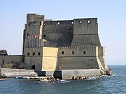
The Castle Nuovo and Church

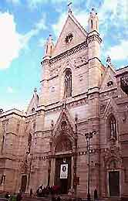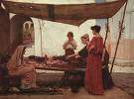
The Great Naples Cathedral Local Textile Market

