Genoa

Products for Trade: Precious metals ( Gold, Silver ) in bars, iron, wines, oil, wax, and textiles.
Trade is conducted with other Italian ports and throughout the Mediterranean region.

Weather: Winters are dry, mild and sunny, 45 to 50 degrees.

Places of Interest to Tourists: The beautiful Church of San Donato, the Palazzo Reale, and the Ducal Palace, where merchants may stay while traveling, are frequent tourist attractions.

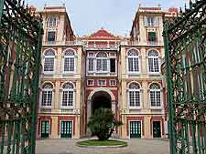
The Pallazo Reale
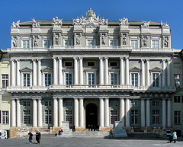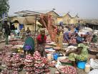
The Ducal Palace of Genoa A Genoa Market

